Project Development Phase
Model Performance Test

Date | 09 March 2026
Team ID | SWTID-2026-3787
Project Name | Project - Automating Data Import and Relationship Mapping Using Import Sets & Dot Walking
Maximum Marks

Model Performance Testing:
Project team shall fill the following information in model performance testing template.
S.No. | Parameter | Values | Screenshot
 | Model Summary | - | 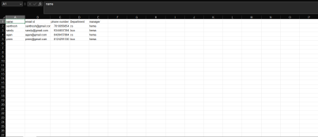
 | Accuracy | Training Accuracy -  Validation Accuracy -
3. | Fine Tunning Result( if Done) | Validation Accuracy -

